**Instructions and patents for Intendal Coated Stent**

**Abstract**

The present invention belongs to the field of interventional medical device technology and discloses an intestinal coating stent. The stent includes a stent body surrounded by a mesh like sidewall, with open ends and a hollow interior. The stent body consists of a proximal support section, a distal support section, and an open section connecting the proximal and distal support sections. The proximal support section is divided into a front section, a middle section, and a rear section that are coaxially connected in sequence. The front section is umbrella shaped, with the umbrella opening facing the middle section. The middle section is tubular, and its diameter is smaller than that of the open section. The rear section is spherical or hemispherical, with the maximum diameter of the rear section being larger than that of the open section but not exceeding the maximum diameter of the umbrella shaped front section. The surface of the stent body is coated, and a non coated opening is provided in a localized area of the sidewall of the open section. This non coated opening allows liquid substances to pass through and flow into the hollow interior of the stent body, ultimately reaching the port of the proximal support section.

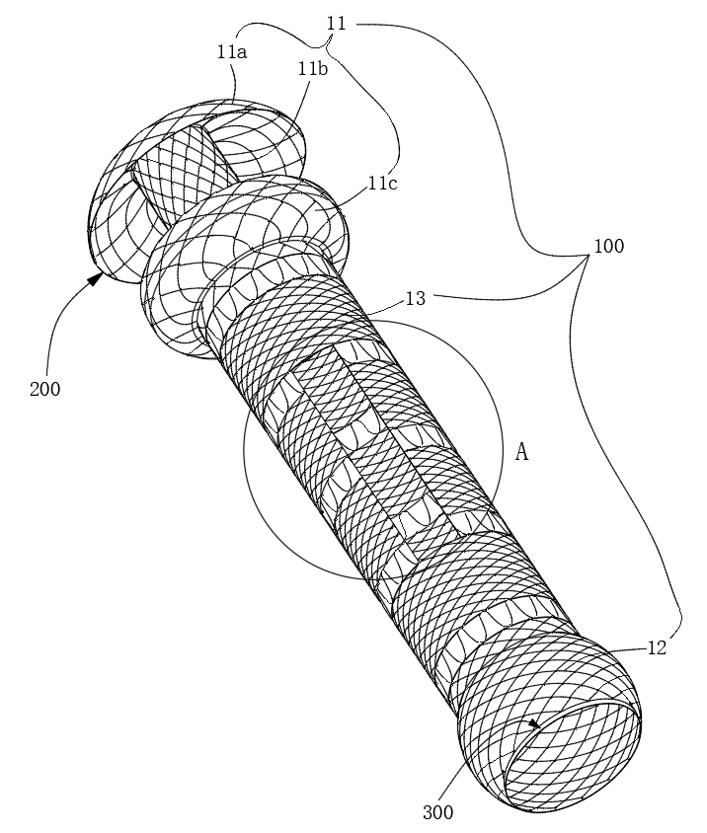

Figure1 Example diagram of bracket

1.Intestinal Coated Stent , comprising a stent body (100) formed by a mesh sidewall, with open ends and a hollow interior; wherein the stent body (100) includes a proximal support section (11), a distal support section (12), and an open section (13) connecting the proximal and distal support sections (11) and (12); The proximal support section (11) is divided into a front section, a middle section, and a rear section, which are coaxially connected in sequence; The front section is umbrella shaped, with the umbrella opening facing the middle section; The middle section is tubular, and its diameter is smaller than the diameter of the open section (13); The rear section is spherical or hemispherical, and the maximum diameter of the rear section is greater than the diameter of the open section (13) but does not exceed the maximum diameter of the umbrella shaped front section.

2.Intestinal Coated Stent, according to claim 1, wherein in the operational state: The front section of the proximal support section (11) is located in the stomach and abuts against the inner wall of the stomach; The middle section of the proximal support section (11) is located within the pylorus; The rear section of the proximal support section (11) is located in the duodenal bulb and abuts against the duodenal wall of the duodenal bulb.

3.Intestinal Coated Stent, according to claim 1, wherein the stent body (100) has a coating (200) on its surface, and a non coated opening (14) is provided in a localized area of the sidewall of the open section (13), which allows liquid substances to pass through and flow into the hollow interior of the stent body (100), ultimately reaching the port of the proximal support section.

4.Intestinal Coated Stent, according to claim 3, wherein in the operational state, the non coated opening (14) is located outside the duodenal papilla, and the opening edge of the non coated opening (14) abuts against the surrounding duodenal wall of the duodenal papilla.

5.Intestinal Coated Stent, according to claim 3, wherein the coating (200) extends outward from both ends of the stent body (100), forming a skirt (300).

6. Intestinal Coated Stent, according to claim 1, wherein the distal support section (12) is spherical or hemispherical, and the maximum diameter of the distal support section (12) is greater than the diameter of the open section (13) but does not exceed the maximum diameter of the rear section of the proximal support section (11).

7.Intestinal Coated Stent, according to claim 1, wherein the axial total length of the stent body (100) is 140 142mm.

8.Intestinal Coated Stent, according to claim 7, wherein:

The axial length of the proximal support section (11) is 30 32mm;

The axial length of the distal support section (12) is 16 18mm, with a minimum diameter of 24mm and a maximum diameter of 30mm.

9.Intestinal Coated Stent, according to claim 8, wherein the axial length of the front section of the proximal support section (11) is 9 9.5mm, with a minimum diameter of 14mm and a maximum diameter of 40mm.

10. Intestinal Coated Stent, according to claim 8, wherein the axial length of the rear section of the proximal support section (11) is 11 13mm, with a maximum diameter of 36mm.

Intestinal Coated Stent

Technical Field

The present invention belongs to the field of interventional medical devices, specifically related to an intestinal coated stent.

Background Art

Currently, self expanding metallic stents are widely used in the treatment of gastrointestinal obstruction diseases, including those in the esophagus, duodenum, colon, and bile ducts. These stents can be either coated or uncoated.

Uncoated stents: These stents can effectively prevent displacement through mucosal proliferation in the digestive tract, but they face challenges such as difficulty in removal and potential damage to surrounding tissues and organs.

Coated stents: These stents have the advantage of being easily removable, but their positioning is often poor, and they may displace once inserted into the digestive tract. Additionally, due to their completely enclosed structure, they present risks of failed fistula closure. For example, when using a coated duodenal stent to seal an intestinal fistula, the stent can obstruct the duodenal papilla, leading to long term pressure on the papilla and affecting the drainage of bile and pancreatic juice. Moreover, bile and pancreatic juice that manage to escape the stent may flow along the surface of the stent and enter the fistula, reducing the effectiveness of the closure or causing failure.

Invention Summary

To solve the aforementioned problems in the prior art, the present invention provides an intestinal coated stent designed to improve its effectiveness and ease of use.

Technical Solution:

The intestinal coated stent includes a stent body (100) formed by a mesh sidewall, with open ends and a hollow interior. The stent body (100) comprises:

A proximal support section (11),

A distal support section (12),

An open section (13) connecting the proximal and distal support sections.

The proximal support section (11) is divided into three coaxially connected segments: a front segment (11a), a middle segment (11b), and a rear segment (11c).

The front segment (11a) is umbrella shaped, with the umbrella opening facing the middle segment (11b).

The middle segment (11b) is tubular, with its diameter smaller than the open section (13) diameter.

The rear segment (11c) is spherical or hemispherical, with a maximum diameter larger than the open section (13) diameter but not exceeding the maximum diameter of the umbrella shaped front segment.

A coating (200) is applied to the surface of the stent body (100), and a non coated opening (14) is positioned in a localized area of the open section's sidewall. This opening allows liquid substances to pass through and flow into the hollow interior of the stent body (100), eventually reaching the port of the proximal support section.

Specific Usage: In the operational state, the front segment (11a) of the proximal support section is located in the stomach, where it abuts the stomach wall. The middle segment (11b) is positioned within the pylorus, and the rear segment (11c) is located in the duodenal bulb, abutting the duodenal wall. The non coated opening (14) is located outside the duodenal papilla, and its edge abuts the surrounding duodenal wall of the papilla.

Advantages Over Prior Art:

1.Improved Stability: The proximal support section is divided into three segments (front, middle, and rear), each serving a specific function:

The front segment is umbrella shaped and stabilizes against the stomach wall.

The rear segment is spherical or hemispherical and stabilizes against the duodenal bulb.

These features ensure that the entire stent body remains securely positioned at the pylorus, preventing displacement and minimizing damage to surrounding tissues.

2. Effective Fistula Sealing: The non coated opening (14) positioned outside the duodenal papilla allows bile and pancreatic juice to flow directly into the stent and return through the proximal port back to the stomach. This design helps to prevent bile and pancreatic juice from leaking into the fistula, ensuring effective fistula closure while promoting digestion in the stomach.

Figures Description:

Figure 2: Perspective view of the intestinal coated stent.

Figure 3: Enlarged view of section A in Figure 2.

Figure 4: Plan view of the intestinal coated stent.

The following elements are labeled:

Stent body: 100

Coating: 200

Skirt: 300

Proximal support section: 11

Distal support section: 12

Open section: 13

Non coated opening: 14

Specific Implementation:

As shown in Figure 2, the intestinal coated stent comprises a stent body (100) made of a mesh sidewall, with open ends and a hollow interior. The stent body (100) is coated with a coating (200) extending outward to form a skirt (300).

Total axial length of the stent body (100): 140 142mm, preferably 141mm.

Proximal support section (11): 32mm, divided into three coaxial segments:

Front segment (11a): Umbrella shaped, 9.5mm in axial length, with a minimum diameter of 14mm and a maximum diameter of 40mm.

Middle segment (11b): Tubular, with a diameter of 14mm.

Rear segment (11c): Spherical or hemispherical, with a length of 12mm and a maximum diameter of 36mm.

Distal support section (12): Spherical or hemispherical, with a length of 17mm, a minimum diameter of 24mm, and a maximum diameter of 30mm.

Open section (13): Tubular, with a diameter of 24mm.

Non coated opening (14): Positioned in the sidewall of the open section (13), measuring 8mm x 45mm.

Procedure for Use:

1.Step A: The intestinal coated stent is mounted on the outside of the endoscope, and three 30mm loop catchers are used to contract the proximal support section (11), distal support section (12), and open section (13).

2.Step B: The endoscope, along with the stent and catchers, is introduced into the digestive tract, ensuring that: The front segment (11a) is in the stomach, pressing against the stomach wall. The middle segment (11b) is in the pylorus. The rear segment (11c) is in the duodenal bulb, pressing against the duodenal wall. The non coated opening (14) is outside the duodenal papilla, with the opening edge against the surrounding duodenal wall.

3. Step C: The loop catchers are released sequentially to deploy the stent.

4.Step D: Adjust the position of the stent using foreign body forceps.

5.Step E: Withdraw the endoscope, completing the fistula sealing.

In summary, the design of the stent, with its segmented proximal support section and non coated opening, ensures secure placement and effective fistula closure while promoting digestive function by allowing bile and pancreatic juice to flow back into the stomach.



Figure2 Perspective view of the intestinal coated stent.

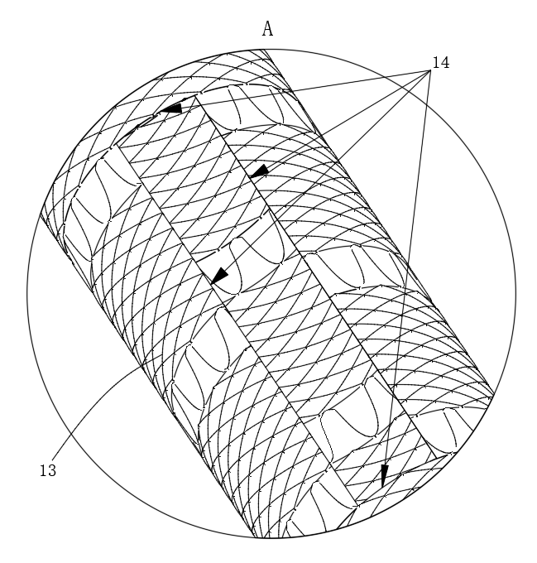Figure3 Enlarged view of section A in Figure 2.

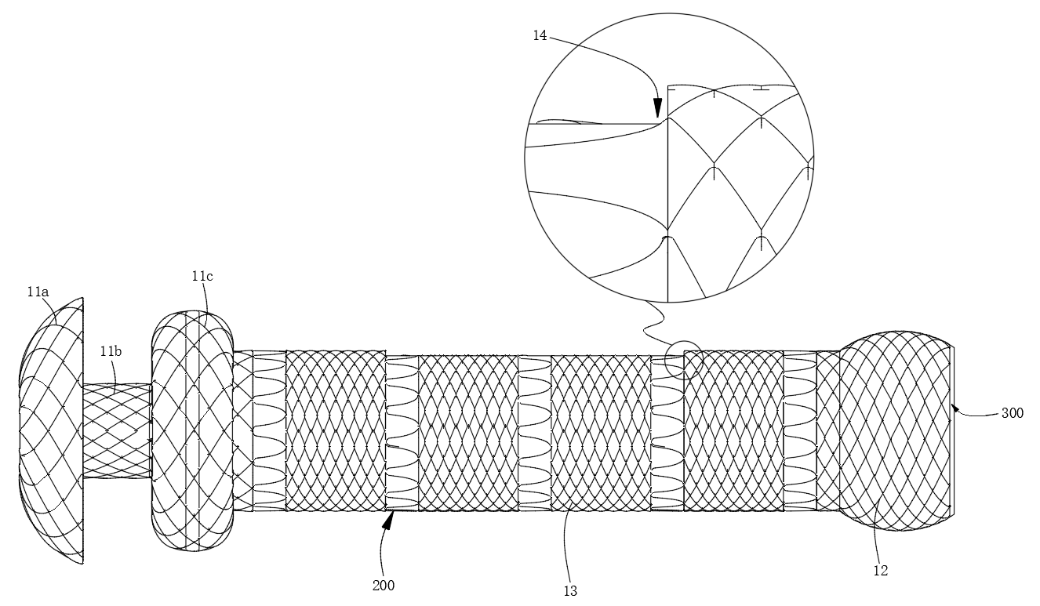

Figure4 Plan view of the intestinal coated stent.

This bracket has obtained patents from China, Japan, and the United States.

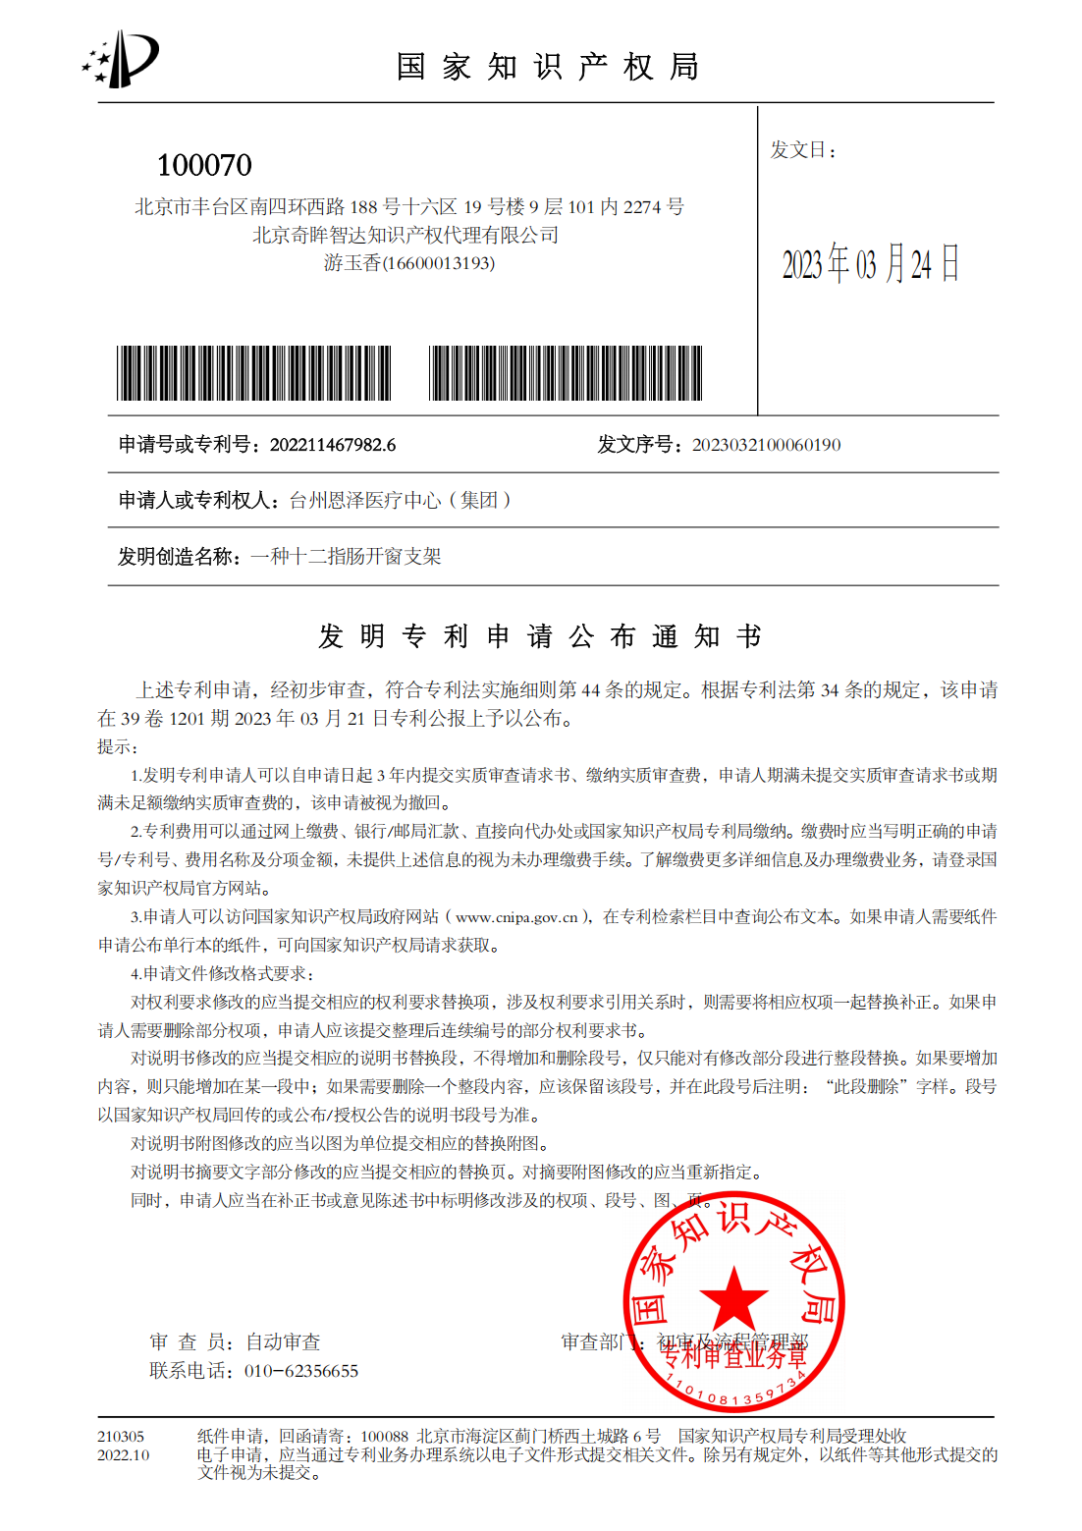

Figure5 Chinese patents.

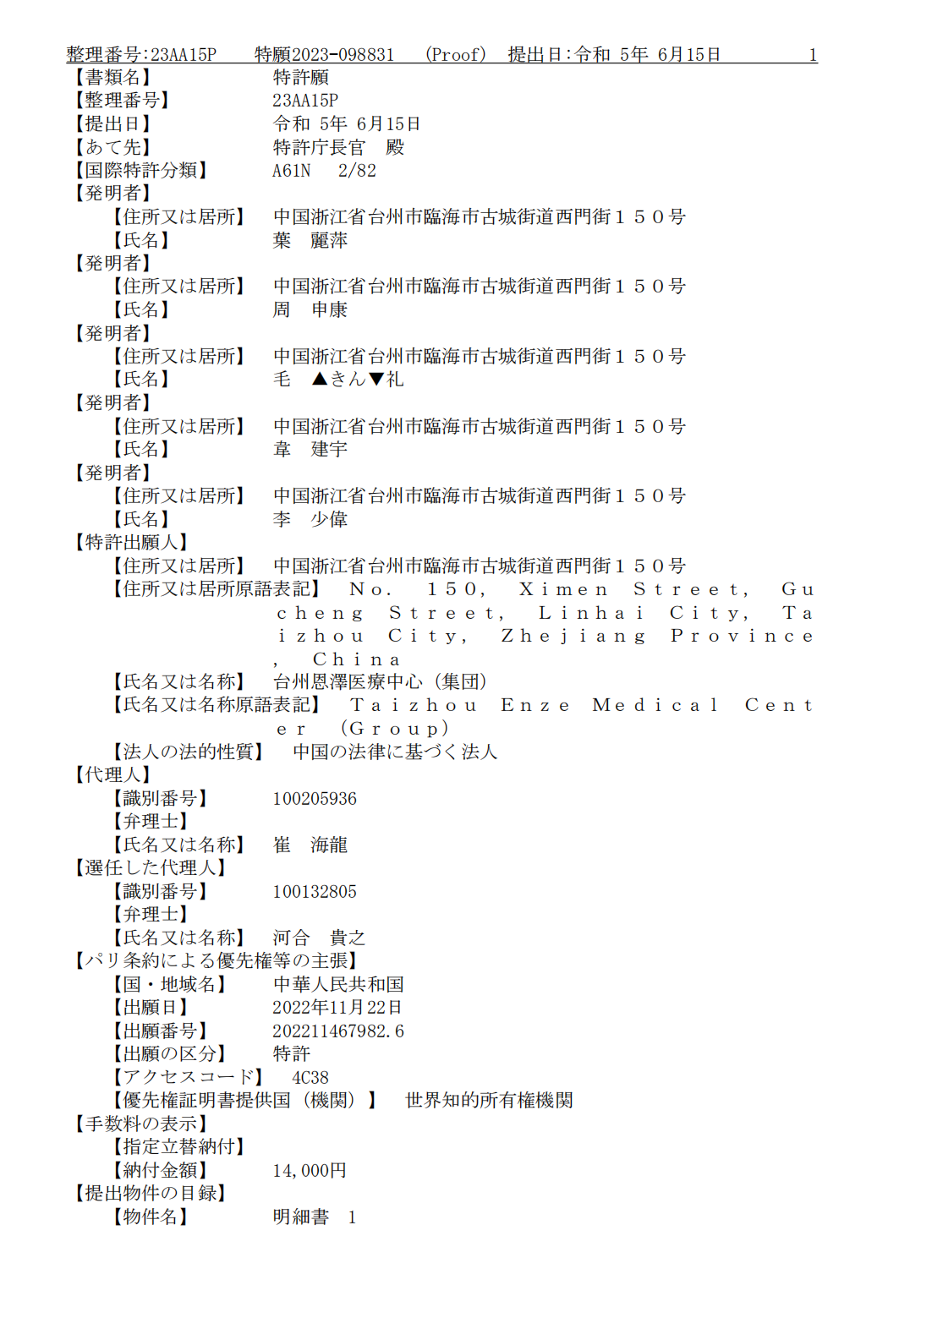Figure 6 Japanese patents.

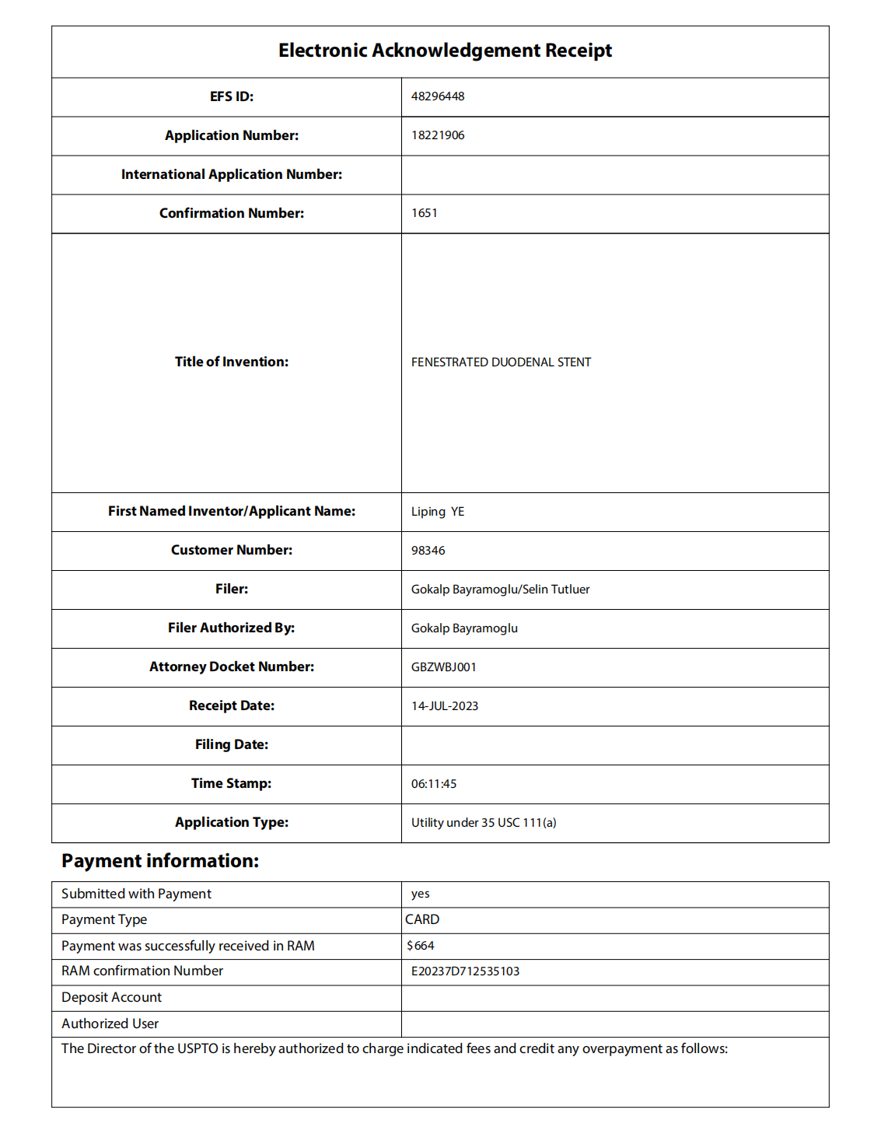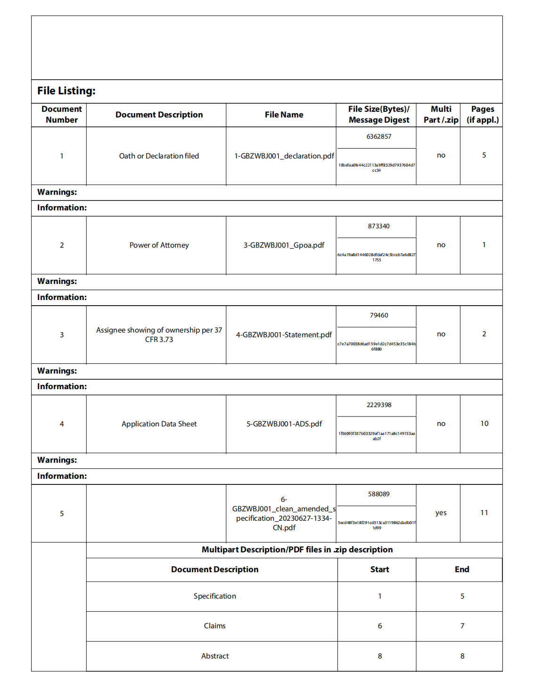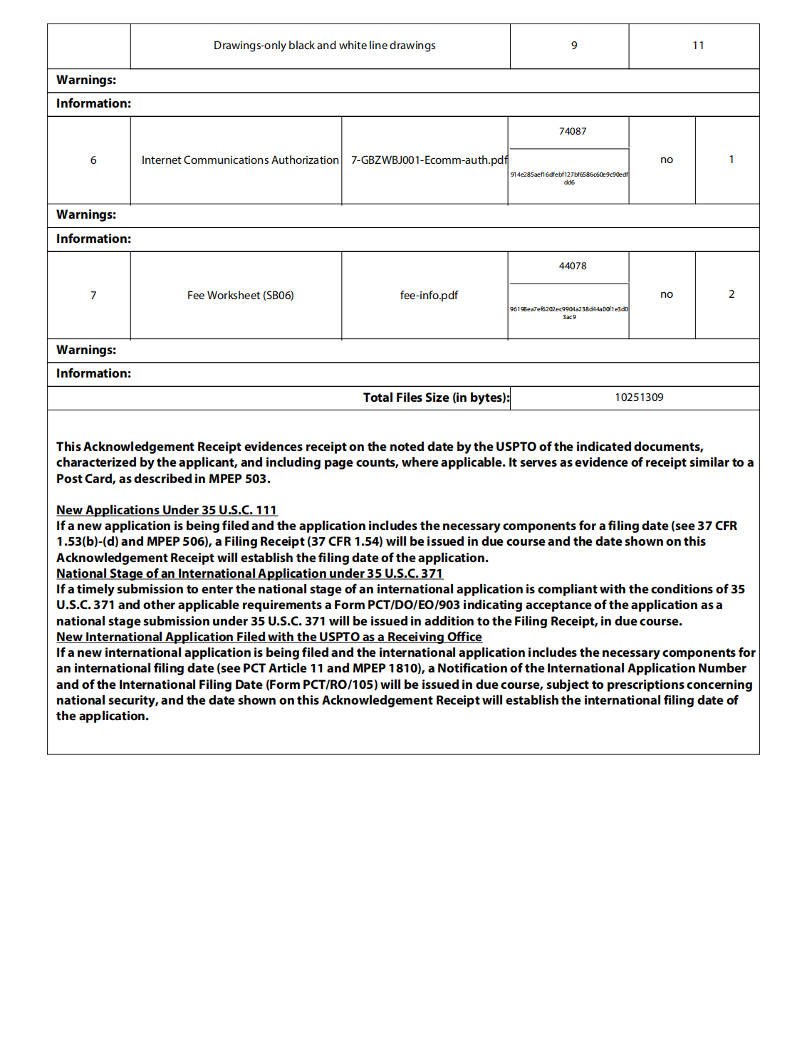

Figure 7 Patents in the United States.